The Disposition of a King TEXT: Matthew 27:26-54

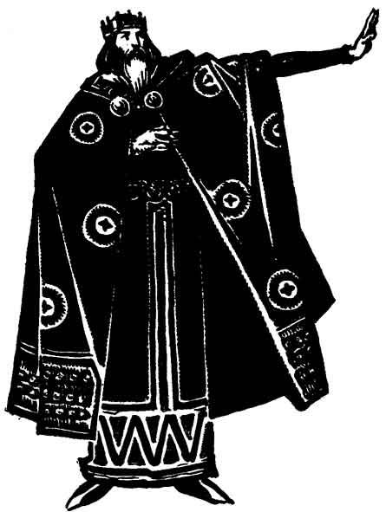There is much about being a man, leadership, and ‘kings’ that is false, because we define them by false weights. **How does a king think and act KINGLY?**

## Introduction

### Disposition

**DEFINITION**: natural mental and emotional outlook or mood; the way in which something is placed or arranged, especially in relation to other things.

**Luke 2:49**—*And he said unto them, How is it that ye sought me? wist ye not that* ***I must be about my Father's business****?*

### The King

The greatest man who ever lived is the God-man: JESUS CHRIST! He was Divine and yet human. He demonstrated excellence and leadership in every area of His life—HE IS THE KING.

**Matthew 2:2**—*Saying, Where is he that is* ***born King*** *of the Jews? for we have seen his star in the east, and are come to worship him.*

### The King’s Men

**Acts 4:13**—*Now when they saw the boldness of Peter and John, and perceived that they were unlearned and ignorant men, they marvelled; and they took knowledge of them, that* ***they had been with Jesus.***

**Successful leaders produce leaders. (Daniel 5:8-9,17)**

**Deuteronomy 28:13**—*And the LORD shall make thee the head, and not the tail…*(compare vs.15)

## His Disposition Toward Self

**Matthew 26:38,39—***Then saith he unto them, My soul is exceeding sorrowful, even unto death: tarry ye here, and watch with me.*  ***39*** *And he went a little further, and fell on his face, and prayed, saying, O my Father, if it be possible, let this cup pass from me: nevertheless not as I will, but as thou wilt.*

**Ephesians 5:25**—*Husbands, love your wives, even as Christ also loved the church, and gave himself for it;*

**The commitment of a king is never to himself, but to his God and to his people.**

**ILLUST:** It is said that Cyrus, the founder of the Persian Empire, once had captured a prince and his family. When they came before him, the monarch asked the prisoner, "What will you give me if I release you?" "The half of my wealth," was his reply. "And if I release your children?" "Everything I possess." "And if I release your wife?" "**Your Majesty, I will give myself**."

## His Disposition Toward Sin

Much is said about a person by their disposition toward sin. You Arrive to the Fire with Two Buckets (Fire and Gasoline).

**Matthew 27:45,46**— *Now from the sixth hour there was darkness over all the land unto the ninth hour.* ***46*** *And about the ninth hour Jesus cried with a loud voice, saying, Eli, Eli, lama sabachthani? that is to say, My God, my God, why hast thou forsaken me?*

**Sin is an enemy that effectively divides us from those who love us best.**

## His Disposition Toward God

A.W. Tozer says that people who are crucified with Christ have three distinct marks:

1. they are facing only one direction,

2. they can never turn back, and

3. they no longer have plans of their own.

**ILLUSTRATION**: During his reign, King Frederick William III of Prussia found himself in trouble. Wars had been costly, and in trying to build the nation, he was seriously short of finances. He couldn't disappoint his people, and to capitulate to the enemy was unthinkable. After careful reflection, he decided to ask the women of Prussia to bring their jewelry of gold and silver to be melted down for their country. For each ornament received, he determined to exchange a decoration of bronze or iron as a symbol of his gratitude. Each decoration would be inscribed, "**I gave gold for iron, 18l3.**" **The response was overwhelming**. Even more important, these women prized their gifts from the king more highly than their former jewelry. The reason, of course, is clear. The decorations were proof that they had sacrificed for their king. Indeed**, it became unfashionable to wear jewelry**, and thus was established the Order of the Iron Cross. Members wore no ornaments except a cross of iron for all to see. **When Christians come to their King, they too exchange the flourishes of their former life for a cross**.

## His Disposition Toward Others

**Luke 23:34**—*Then said Jesus, Father, forgive them; for they know not what they do. And they parted his raiment, and cast lots.*

**John 19:26,27***— When Jesus therefore saw his mother, and the disciple standing by, whom he loved, he saith unto his mother,* ***Woman, behold thy son****! 27 Then saith he to the disciple,* ***Behold thy mother****! And from that hour that disciple took her unto his own home.*

**ILLUSTRATION**: The” Goose V”. Each goose creates a greater updraft for the goose behind them. 71% greater flying range. Stay in Formation.

**The King understands the greatness of his responsibility and knows how to share the load.**

## Conclusion

**Philippians 2:7,8**— *But made himself of no reputation, and took upon him the form of a servant, and was made in the likeness of men:*  ***8*** *And being found in fashion as a man, he humbled himself, and became obedient unto death, even the death of the cross.*

**The robe did not make the king, but it is the king that makes the robe.**

**They mocked him “King of the Jews!” And then took away their robe of mockery. But, they could not change Who He was!**

**Matthew 27:54**—*Now when the centurion, and they that were with him, watching Jesus, saw the earthquake, and those things that were done, they feared greatly, saying, Truly this was the Son of God.*

The KING is Committed, Determined, Decided, Resolved, Involved, the Leader, and in his own opinion: **last**.